**UMass Boston Physics 181**

**Hooke’s Law**

**Pre-lab Test (10 Points*)***

**Print Name** **_________________________________________________________**

**Lab Section _____ Date___________TA_________________________________**

**This Pre-lab is due when you come in to do the experiment. Show formulas and results as specified below, but you should use Excel to perform the numerical calculations.**

1. In this experiment, a *0.20 kg* mass (m1) hangs vertically from a spring and an elongation of the spring of

*9.50 cm* (r1) is recorded. With a mass (m2) of *1.00 kg* hanging on the spring, a second elongation (r2) of *12.00 cm* is recorded. Calculate the spring constant *k* in Newtons per meter (N/m). (Note: The equilibrium position is *not* zero.)



*k =*

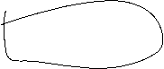

1. If the same spring (as in part 1) causes an elongation (r3) of *18 cm* when a mass (m3) is attached to it, what will be the mass in SI units?

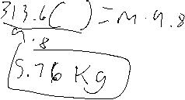

*m3 =*

1. If the same mass (m3) causes an elongation (r4) of *5 cm* when it is attached to a different spring, what will be its spring constant *k* in Newtons per meter (N/m). The equilibrium position is *1.3 cm*.

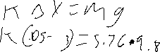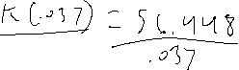

*k =*

